Advancing Accessible 3D Design for the Blind and Visually-Impaired via Tactile Shape Displays

【Summary】：

The thesis aims to create accessible 3D design and printing workflows for BVI by using a 2.5D haptic display, and a strict understanding of how BVI uses work in the context of perception, interaction, and learning.

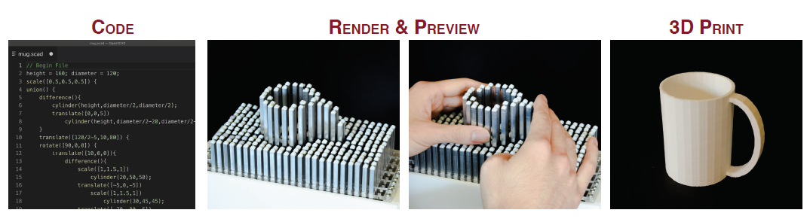

【Thesis focuses on 3 questions】：

• How can complex 3D information be effectively encoded through tactile representations?

• What are the interaction techniques necessary to create and manipulate 3D models on tactile displays with limited resolution?

• How does access to 3D design and printing in the wild for BVI people change their self efﬁcacy of making and their attitudes towards STEM?

【Thrust 1: Representing Spatial 3D Information】：

1. to elucidate on the beneﬁts of the different encoding representations for 3D spatial information; compare contours versus reliefs.
2. to understand the in-terplay of tactile array resolution (low, medium, high).

【Thrust 2: Co-Design of an Accessible 3D Modelling System Supported by Tactile Displays】:

Look at the paper in detail, and his previous work

【Thrust 3: Long-Term Deployment To Assess Learning and Self-Efﬁcacy】：

back gathered will allow me to frame insights for future educators and researchers on: 1) guiding tenets and continuing challenges for accessibility in Makerspaces, 2) necessary software and hardware support, 3) a repository of 3D models to inspire future domain speciﬁc design tools, and 4) recommendations for course design and integrated classroom dynamics.

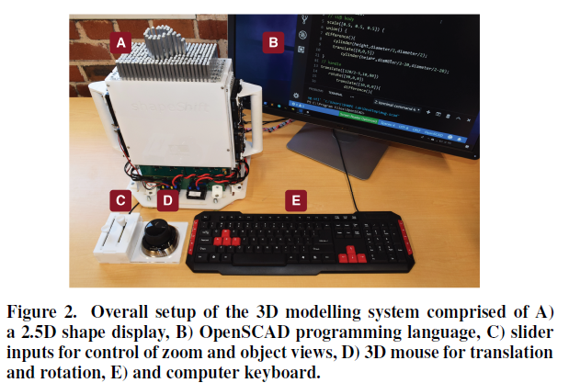 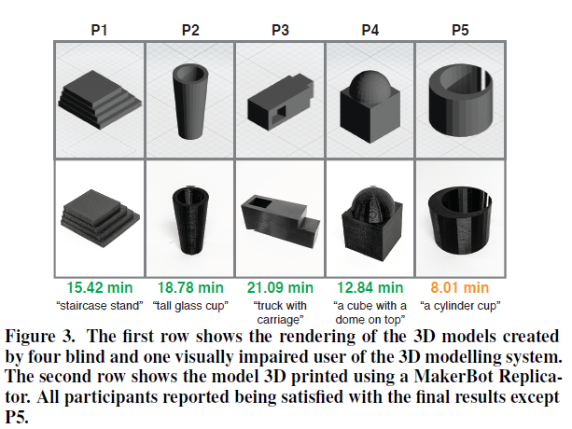

【Important Reference】:

[12] Rebecca Lawson and Sarah Bracken. 2011. Haptic Object Recognition: How Important are Depth Cues and Plane Orientation? Perception 40, 5 (2011), 576–597. DOI:http://dx.doi.org/10.1068/p6786 PMID: 21882721.

[13] Susan J Lederman and Roberta L Klatzky. 1987. Hand movements: A window into haptic object recognition. Cognitive Psychology 19, 3 (1987), 342 – 368. DOI: http://dx.doi.org/https: //doi.org/10.1016/0010-0285(87)90008-9

[14] Fabrizio Leo, Elena Cocchi, and Luca Brayda. 2017. The effect of programmable tactile displays on spatial learning skills in children and adolescents of different visual disability. IEEE Transactions on Neural Systems and Rehabilitation Engineering 25, 7 (2017), 861–872.

[16] Thomas Pietrzak, Andrew Crossan, Stephen A Brewster, Benoît Martin, and Isabelle Pecci. 2009. Exploring geometric shapes with touch. In IFIP Conference on Human-Computer Interaction. Springer, 145–148.

[17] Denise Prescher and Gerhard Weber. 2017. Comparing Two Approaches of Tactile Zooming on a Large Pin-Matrix Device. In IFIP Conference onHuman-Computer Interaction. Springer, 173–186.

[19] Ravi Rastogi, TV Dianne Pawluk, and Jessica Ketchum. 2013. Intuitive tactile zooming for graphics accessed by individuals who are blind and visually impaired. IEEE Transactions on Neural Systems and Rehabilitation Engineering 21, 4 (2013), 655–663.

[20] Alexa F Siu, Eric J Gonzalez, Shenli Yuan, Jason B Ginsberg, and Sean Follmer. 2018. shapeShift: 2D Spatial Manipulation and Self-Actuation of Tabletop Shape Displays for Tangible and Haptic Interaction. In Proceedings of the 2018 CHI Conference on Human Factors in Computing Systems. ACM, 291.